CMPUT 455 Notes
- Go is invented in China
- Rules:
  - Black goes first
  - To move, place on an intersection
  - Blocks are stones which are connected to each other except diagonally
  - Empty points are called liberties
  - If a stones liberties are all gone by the opposing player, the stone is captured and removed from board
  - Suicide is when a players takes aways its own last liberty which is illegal
    - Capture>Suicide
  - Ko is when stones are continuously captured in an infinite loop such as in the following example. We can force them to play somewhere else to avoid this
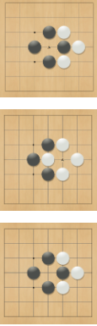
  - Therefore a legal move is when a stone is played on an intersection which avoids ko or suicide
  - A pass move is when the player decides not to add a stone on the board and after two successive passes, he game ends
  - To decide winner, count number of stones and territories for both players and adjust the handicap(known as komi) and whoever has the highest one wins. Draws are possible.
- MCTS(Monte Carlo Tree search) helped Go programs become what they are today
- Go0 algorithm:
  - 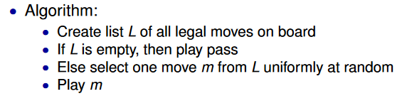
- Problem with Go0
  - Takes own liberties
  - Doesn’t end after two passes so game never ends
- An eye is a point surrounded by a colour and make it illegal to play on it
  - A player having more than one eye is safe
- To recognize an eye
  - Check if all neighboring points(not just liberties) are connected and of the same colour
- Go1 avoids filling simple eyes
- Rules of NoGo:
  - Same as go but
  - Capturing/passing is illegal now therefore player to make last move wins
- We need efficient board representation as we need to play billions of moves and taken back and we need to search for many possible moves
- We use an enum type to store states
- We can use a 2d array to store the array but overhead from 2d calculation is tough. Also tough for boundary cases.
- We use a 1D array to store them by using x and y as the following pos= x+y*MaxSize of board. Issue I the edge of the board has special cases and it is not necessarily true that sequential numbers are neighbors
  - We can add padding above and below board and in between the rowsa
    - Gives us 8 neighbors which are valid array indicies
    - No wraparound to next line
    - Can check if boarder easily
- Branch predictor
  - We check early instruction and the process will guess the value in a conditional branch. Therefore if it guess wrong, all progress is lost.
- If we use play_move(p, colour) in the board.py file, we put the colour in point p although we need to check if it is legal before we can actually play the move
- To authorize a capture, check if all block liberties and if it is a capture, go for it. We then update the board
  - 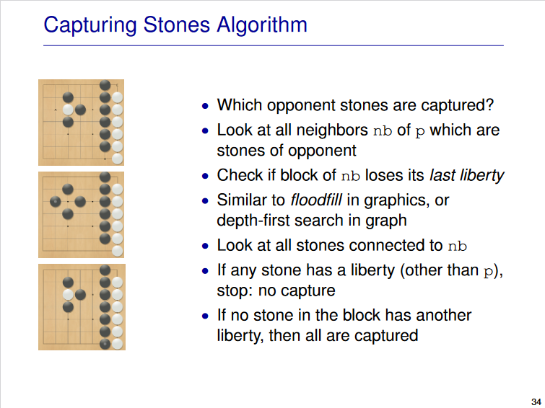
  - We can use flood fill
    - Mark points visited and visit all of their neighbors. Recursively visit the neighbor of correct colour. Use DFS.
    - Idea is as follows:
      - Look for connected stones and check if it still has liberties or not
- Tromp Taylor rules give more formal rules for GO
  - 19x19 board
  - Points on board are either B,W or empty
  - Let a point=P and colour=C. P is said to reach C (when not coloured C) if a path of adjacent points of P’s colour from P to a point of C
  - To clear a colour from the board, we empty all points of said colour which don’t reach empty
  - Black starts
  - A turn is either compromised of a pass or a nonrepeating grid coloured move
  - A move is when one colours an empty point with own colour and then clearing opposing colour and then clearing ones own colour
  - 2 passes=game over
  - Score =Num of stones+empty territories reaching said stones
- To check if a move is legal, we check the following
  - If the current position in board is empty
  - If it not a suicide move
    - Check if the block/stone has any liberties remaining
    - To check in Go0, do the following
    - 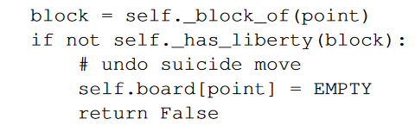
  - If it is not a repetition
    - A lot more complex and expensive is done naively
    - For Ko:
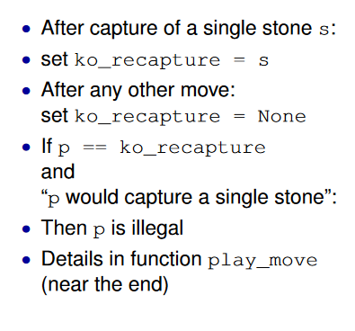
- Undo is possible but not in Go1&Go0
  - When doing a search, we can consider multiple moves
  - Idea is to take back one move before goin for another, but if a stone is captured it becomes difficult
  - 2 possible methods in:
    - Copy and modify:
      - Each move, you copy and modify the board and then make said copy the new board
      - Push boards onto a stack and when we undo, we pop the stack and use prev one
      - Simple and fast but uses too much memory due to excessive copying
    - Incremental Stack Change
      - One board + stack
      - We push a marker onto stack hence recording each change an storing said value on stack
      - To undo a move we restore the old values based on values in stack and stop when we reach special marker
      - Less operations are done but more branching will occur
- Decision making is important in real life and path fining
- Various questions arise when dealing with it such as if we can model it in a game program or if we can teach effective decision making to others
- 2 main research strands
  - Normative Theory:
    - Analyze the problem and tell user what is the best action
  - Descriptive:
    - Analyze how real agents make decisions where a real agent is a human or sometimes a smart program.
- Game theory
  - The idea here is that selfish players will try to maximize their expected value
  - Think of a two player zero sum game
- Recall expected value is $\sum_{i=1}^{n}{p_{i}v_{i}}$
  - P_{i} is is the probability of the ith value and v_{i} is the number value of the i-th element
  - If, for example, Fold value is -1 and Bid value has(+5 with a probability of p and -3 with probability of 1-p), to be indifferent the expect value of bidding must be equal to that of the fold. If p leads to a value smaller, go for the fold and if EV is bigger than -1, betting is better. Do note scaling the values for folding and betting will drastically change the EV.
- St. Petersburg paradox deals with expected value vs peoples actual behaviour.
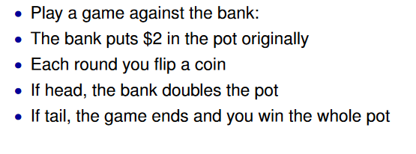
  - EV here is infinity as p to win 2 dollars is ½, ¼ to win 4 1/8 to win 8 etc. Therefore, we have an infinite amount of 1s to be added. Do note the chance to win big is extremely small. This is not even taking into account the price to play itself.
- Utility is the measure of satisfaction of a consumer with an outcome.
  - Utility of money is hard to determine as twice the money is not necessarily desirable
  - Utility function for money maps monetary outcome to utility scale which reflects ones personal preferences.
  - Various behaviours are taken into account:
    - Risk-averse, the utility function has a slower growth than that of a linear (risk neutral)
    - Risk neutral: linear utility function
    - Risk-seeking: Faster than linear growth
- Marginal Utility: Increase in consumer satisfaction from having one more of a unit
- Maximum Expected utility principle is the principle of trying to maximize ones expected utility
  - Can calculate it in the same way as expected value but replace the value with the utility value
- Its nearly impossible to estimate singular events
- Heuristic
  - Think of a mental shortcut or rule of thumb
- Exact method is the opposite of a heuristic method
- Polya’s four principles:
  - Understand the problem
    - What is the input, data given, output and their constraints/requirements.
    - Figure out the concepts needed.
    - Break up into smaller problems
  - Devise a plan-Find connection between data and unknown
    - How to compute output via input. If seen before, can re-use?
    - Different way to re-write
    - Write the problem differently in a way one can understand
    - Try solve a special case or an example.
    - Use everything you know and make sure used whole specification and input properties
  - Carry said plan
    - Write function and test
    - Make sure incorrect data is handled correctly
  - Look back
    - Review problem and check solution
    - Split into modules
    - Extend/ generalize the code
- Auxillary problem:
  - Find easier problem to solve OG problem.
  - Break up into smaller problem to solve bigger one
- Optimization is the act of finding the best possible solution to a problem
  - Decision making isn’t necessarily an optimization problem as many factors are too tough to compare but we aim to optimize specific parts
- Humans cant make the best decisions
  - Make decision which are satisficing (optimum solution for simplified or satisfactory solutions for realistic world
- 2 reasoning approaches:
  - Reasoning based on model of world or from direct observations
- People focus on changes in utility than on absolute utility
- Some decision making only takes into account present
  - Reflexes
  - Intuitive decisions
  - When looking ahead isn’t necessary
- We need to think about future to make decisions now
- Thoughts about decision making:
  - Possible actions
  - Goals of others
  - Evaluate different outcomes
  - Limited resources computation
- Assumptions
  - State of world completely known
  - Terminal states where we can evaluate result precisely
  - Possible actions
  - Actions will change the state to a new deterministic way
  - No chance element
- Most single player games follow this but most multiplayer games don’t (some do)
  - Most classic 2 player games do
    - Simple controlled environment
    - Hard to solve/play well
    - Games and results are easy to understand
    - Requires good decision making skills
    - Study core problems of decision-making without being distracted
- State/Game state
  - Gives a description of current situation (in a games cases, it can refer to board position, cards turn etc.)
  - The state plus the rules of the game allow us to determine moves
  - Sometimes stores history depends on rules and search space structure
    - In MDP (Markov Decision problem) history not relevant as current state has all the info
    - Having history only states could work but it could be inefficient as we’d always need to replay all actions from the beginning to find current state
- Action/move
  - Move from one state to another
  - In go, can move in accordance to color or to play info
    - Alternating plays
  - Store all moves played
- State Space:
  - Graph with all possible states with edges representing actions
  - Represented as G(V,E)
    - V represents the game states(Nodes) while E represents the moves (Directed edges). An edge is made of up of previous state and next state
  - Measures of game complexity
    - Branching factor
    - Size of state space
- Terminal state:
  - No possible actions
  - Represented as no outgoing edges in graph
  - For go:
    - When a player resigns or both players pass
    - Usually go till where there are no legal moves left
  - Rewards tend to happen at the end in this state
- Types of state where root is at the top of current state
  - Tree
  - Directed Acyclic Graph (DAG)
  - Directed cyclic graph (DCG)
    - Go without repetitionDCG due to cycles whereas tictactoe is DAG as one can get the same game result regardless of move order
    - Note that GO with full repition rules will lead to a DAG
- Game result
  - Win/loss or win/losss/draw or size of win can be important
- 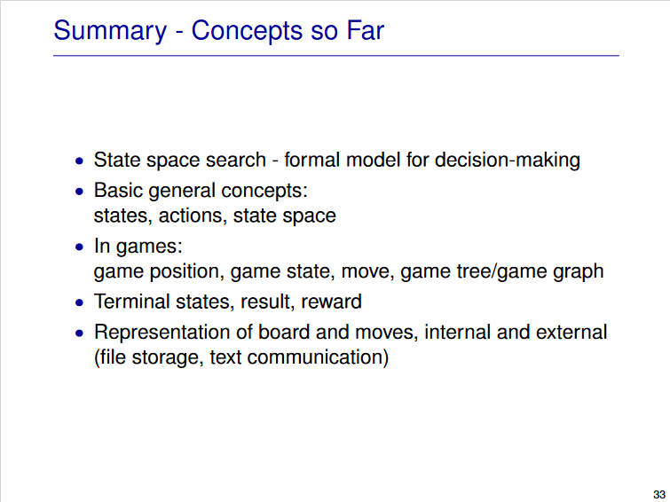
- When representing state, we need to keep it simple but able to show all relevant info
  - Can list rewards for each move or sum them or keep different
  - States with same reward difference are equivalent and if we use difference, we reduce number of states as we can compress history and add it to each state
- Spaces:
  - Tree:
    - One path from root to node
    - Every actionnew state
    - Copy=separate state
    - Ignore if different paths lead to same situation
    - +:
      - Simple
      - No dependencies
      - Single path to each node
    - -:
      - Duplication
      - Large state space
      - Inefficient search due to many copies
    - To illustrate size, assume branching factor b with b children and depth d where each path from root is d actions long
      - Each child will have b new children so at depth 2 we get b² nodes from b nodes in depth 1 and 1 node at root. When we reach depth d, we get b^{d} nodes at depth d and for a large d value, it will be very large
        - Total nodes is 1+ b+ … +b^{n}= (b^{n+1}-1)(b-1)
      - Not necessarily the case as in TicTacToe you don’t remove anything so would get n! possible games where n is the number of choices for a move
- Complexity of solving a game depends on factors such as:
  - Branching factor
  - Depth
  - Simple strategy existence
  - If math theory exists
  - Good heuristics
- Size how many states
- Structure Tree, DAG or DCG
- To estimate search effort:
  - Assume we need to visit every state to solve a game and then we need to see how long it will take
    - Speed of program and size of space is key
- For a 7x7 go board
  - 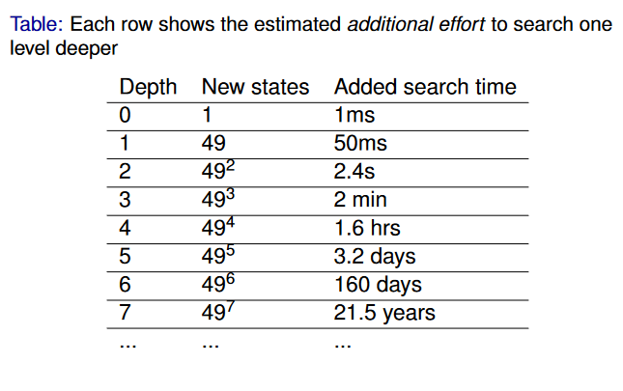
- To decrease exponential growth:
  - Increase program speed
  - Decrease branching factor and/or depth
- We can use a DAG instead of a tree to decrease branching factor or use better search algorithms.
  - One can use symmetry to reduce the state space but a lot of the time will be broken after a few moves. Therefore we mainly use symmetry for the 1st 2 depths.
  - DAGs allow different paths to the same state space as the subtree doesn’t become as complex and can happen throughout the whole game
- Tree vs DAG
  - Each action in tree= new node whereas in DAG all equivalent states=single node
  - In a DAG we can reduce space size and we can avoid redundant computations and we can often reuse calculations.
  - Memory in DAG is a major issue as we need to store/recognize equivalent states. Many algorithms are designed with trees in mind
  - Not always possible to merge into a single node as they aren’t always equivalent and sometimes the board might look the same but the moves used are different
- At depth d: there is a ceiling(d/2) black stones and floor(d/2) white stones in a simple gomoku game.
- You can use combinations to count the number of different ways to place a single coloured stone, and if you wish to deal with 2 different coloured stones, you multiple the 2 combinations by each other
- In a DAG, depth affects branching factor and thus to get branching factor at depth d, we divide the number of nodes in the next depth by the number of nodes in current depth
- To count the number of nodes in a DAG at depth n, we multiple all the branching factors up to depth n-1…so (b0*b1*….b_n-1)
- To get the total number of nodes up to depth n, we add all the nodes nodes in the previous depths (so 1+b_0+b_0*b_1+….. b0*b1*….b_n-1)
  - There isn’t a closed form solution for this
  - For large games, it is very difficult to compute
- For TicTacToe it is close but as we have one less square with each move, it is a little different(b_0-n) for depth n
- Complexity depends on board size
- Using a 2x2 example, a naïve brute force minimax search goes through trillion of nodes while an alphabeta search with bad move ordering visits 19,397,529 nodes at a max depth of 58 but with good move ordering, it decreases to 1446 nodes up to a max depth of 58.
- Looking at a current state is generally not good enough as we need to consider future states and sequences of actions. We also need to consider short and long term consequences.
- For sequential decisions, we loop the following:
  - Get current state of world
  - Analyze and select action
  - Look at response
  - Loop until done
- Formally:
  - Start state s_0
  - Action a_i leads to state s_i+1
  - keep going till we reach terminal state s_n
  - Store sequences in order of s_0,a_0,s_1s_n but sometimes only action is needed
    - We can also add rewards after each action
    - These are known as full sequences. Partial ones stop after any number of actions ad not at terminal state
- To do sequencetree, take two sequences with largest common prefix and make them a single branch and the split them as soon as they differ. (tree)
- For a DAG, we merge different sequences if they reach an equivalent state
- Recall the following rules:
  - Game ends after 2 passes (some have 3 passes)
  - Scoring:
    - Area: Count own stones plus surrounded empty points
    - Territory: Count surrounded points plus captured stones and prisoners
    - Add komi to both
  - Suicide and repetition is forbidden
    - Longer loops may be difficult to catch
  - Superko: Same board position is forbidden
    - Positional: Ignore whose turn and only compare board
    - Situational: Compare whose turn it is as well
    - To detect this we can do the following:
      - Compare against all previous positions but generally too slow
      - Hashing can be used to detect repetition
- We should optimize if and when needed and is generally important for searching
- Profiling is a good way to check where we spend the most time
  - Profiler tells you details of program execution
    - Can be used in function/instruction level
    - Must import cProfile
    - Note overhead of profiling is also measured
- Amdahls’s law limits speedup
  - Limit= runtime before/runtime after= 1/((1-p)+p/s) where p= percentage of program sped up and s is speed up for that specific part.
    - Sometimes s is very large so we can ignore the p/s in the formula
- We can use low level optimizers and algorithms to speed up Go1
- We first pick a test game and run it with the profiler, figure out where the most expensive functions are and improve them
  - Sometimes its good to look into cumulative time which is the function calls plus other functions it calls
- Optimization strats:
  - Avoid calling functions if possible but if not, avoid unnecessary calcs
- Premature Optimization is root of all evil-Knuth
- We use search to lookup existing info or discover new info
  - Said info may change during search
  - Data stored in either structured or unstructured way
- State space given implicitly in generative model
- Agent is a plyer and can choose every actions
- Blind search: When we search through a space with no extra info
  - Depth first
  - Breadth first
  - We usually can expect to visit about half of all states
    - States are visited in order and each have an equal chance to be a goal node of 1/n. To get to an ith state, we need to visit i+1 states. Thus expected number of visits is 1/(1+2+…._n)=1/n * n(n+1)/2=n+1/2 which is around n/2
    - Noteshape doesn’t matter and we assume each state is only visited once
    - If we use a heuristic, it is no longer blind
    - Some states could be costly to visit
- Random sampling is when we take a random path down tree and see if we reach the goal. Stop when we do and continue to leaf and do a different walk if not
  - Incomplete and probabilistic as we may not get to goal
  - In comparison, DFS and BFS are both complete as they will find the goal node
  - Will have a bias towards the nodes closer to root
- 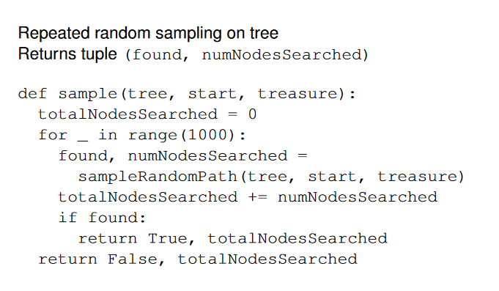
- 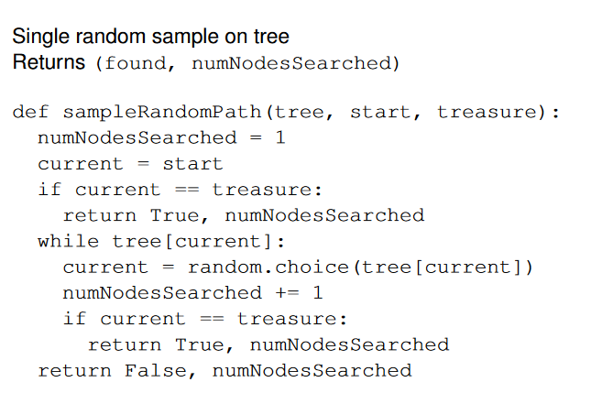
- We use heuristics to guide the search process
  - If we get a good heuristic, we can lower the search effort
  - Useful to search through large state and often better than a blind search
- Exploration is very important as it can look into other parts of state space where the heuristic wont lead us
- Modern heuristics use:
  - Search: The idea of looking ahead systematically. Here we exploit the heuristics and other states
  - Heuristic Evaluation: We see hoe good an action/state is
  - Simulation: By sampling sequences of future states we can look ahead
- A heuristic function estimates the goodness of state s . This differs for single player and 2 players
  - For a single agent, it estimates distance from state s to a goal and the unction should return 0 is the goal r a value greater than 0 otherwise
  - For 2 player zero sum games we have 3 different measures:
    - How likely player to win
      - H(s)=0 if state is a sure loss and 1 if it’s a sure win. We can have values between 0 and 1 as well.
      - Winning probability for opponent is 1- h(S) with the assumption of no draws
    - Players expected score
      - H(s)=-1 if state is a sure loss and 1 if it’s a sure win. We can have values between -1 and 1 as well. Draw is usually 0
      - Opponent payoff is -h(s)
    - What is potential score in the end
      - H(s) is true score if s is a terminal position.
      - Opponent payoff is -h(s)
      - No real requirement for non-terminal states
- Focusing only on heuristic is risky but blindly searching is bad in large state spaces so we need a mix of both
- To solve a game, we need the correct outcome with the best play by both players
- Different solving types:
  - Ultra Week: We know outcome but have no concrete strategies
  - Weakly solved: We have a winning strategy from initial state
  - Strongly solved: provide an alg which can win from any winnable position of game
- We need a winning strategy to play to win
  - We need to win against all of the opponents moves and include all their moves in our strategy
- Winning StrategyDAG/Tree
  - Includes all of the moves in opponents turn and one of ours
- The tree/DAG is smaller than state space as it only branches at the losers turn. Can still be large
- Don’t store winning strategy
- Build top down from root but can build from bottom up
- For a game tree we have 2 different nodes. AND nodes and OR nodes
  - OR nodes corresponds to our turn
  - AND nodes correspond to opponents turn
  - We alternate between the 2
- Leaf nodes are the terminal states and once reached, game is over
- Winning in an OR node:
  - Finding a single winning move is ok
  - A win for node n is when we win in any of the children and can play that move from n
- Winning in an AND node
  - We can only win here after all of the opponents moves
  - i.e. We must win in ALL children nodes and if a single one is a loss we stop as opponent can play that move
- Note above is for trees, we can use similar concepts for DAG but a bit different
  - Store and share wins/loss computed
  - As we can have different paths to the same node we can prove a win for a single node and then remember how to get there
  - We use hash tables to store state/results
- Search Algorithms:
  - Boolean Minimax for an OR node:
    - 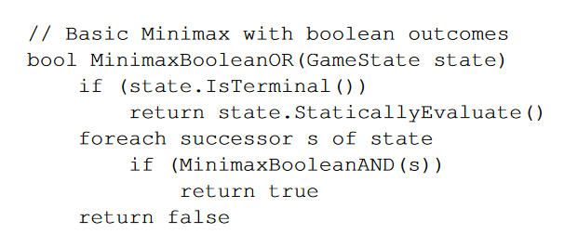
    - If we have a single winning move, we can play that move and we can only lose if all moves lose
    - As this is a zero sum game, opponents win is my loss
    - We can adapt this to deal with undos and move execution
    - 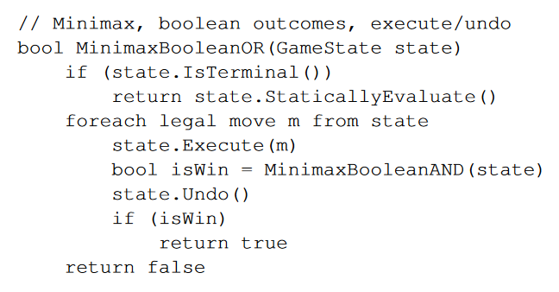
  - Boolean minimax for AND node:
    - 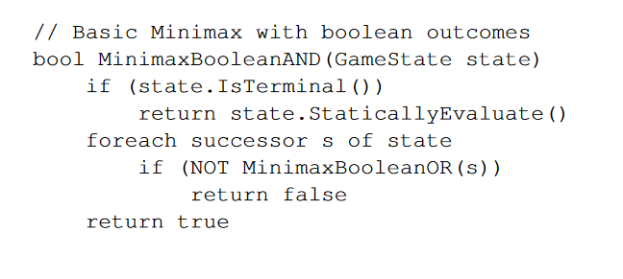
    - Similar to an OR node, we can adapt this further:
    - 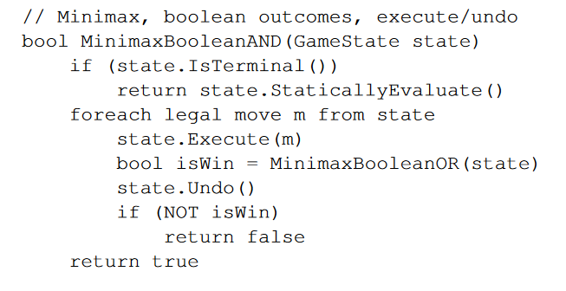
  - Negamax allows us to evaluate the game state from current PoV rather than a fixed players POV. TO accomplish thism we switch PoV with each move and negat the result in a recursive call
    - My win is your loss and vice versa
    - Boolean Negamax:
    - 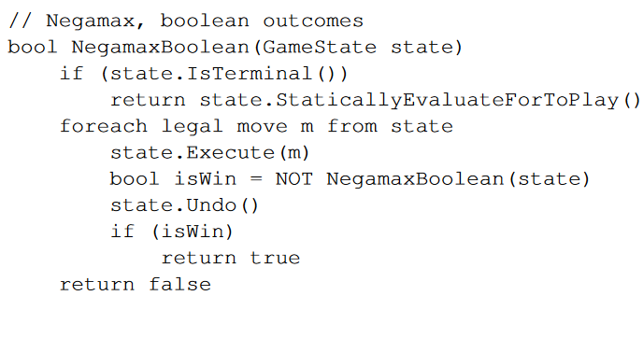
- For Boolean Minimax:
  - Runtime depends on depth of search, width and move order.
  - We can adjust it to compute all wining moves rather than stop at first win
  - Good pruning as it stops in 1st win
  - Number of nodes visited is (b^{d+1}-1)/(b-1)
  - Best case efficiency is b^{d/2} ad it cutoff (early return due to finding winning move) at winning side but worse case is b^{d} as we wont find a cutoff move
- A proof tree is a winning strategy for a player show as a tree to prove that we can win. It is a subset of the game tree
  - Note we can also a disproof tree which proves we cant win
- These cover all possible opponent responses at each point while giving us a winning move in each position we encounter
- Formal definition:
  - 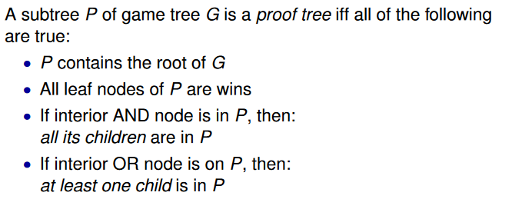
  - Above can also work for DAGs
  - Size of proof tree depends on level:
    - 1 node at root
    - >=1 in level one where the best case is 1
    - >=b in level 2 where best case is b
    - Thus pattern for best case is 1,1,b,b,b^2,b^2,b^3,b^3
- Aim of minimax search id to maximize our score while opponent minimizes ours
- In an OR node
  - We aim to maximize our score and our score would be the max score of children of current node
  - We usually evaluate all nodes unless we have a bound or know highest score possible
  - 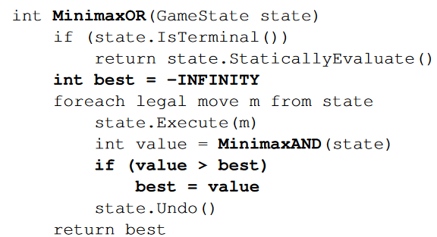
- IN an AND node:
  - They aim to minimize score
  - Score is the min value of all children of current node
  - 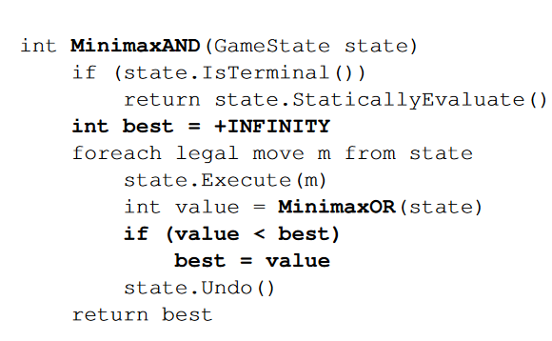
- We call 2 functions recursively(calculate MAX in OR and min in AND) and stop at terminal state
- When using negamax to search for numbers we evaluate from current Players PoV and call it recursively. We can negate the result to switch players and computed the negated max
  - Without pruning:
  - 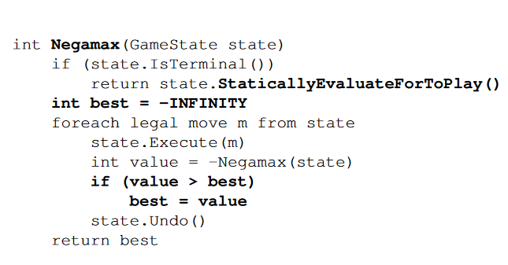
  - Issue is that it is inefficient due to no pruning and will search all paths in a tree
- 2 possible scenarios to fix:
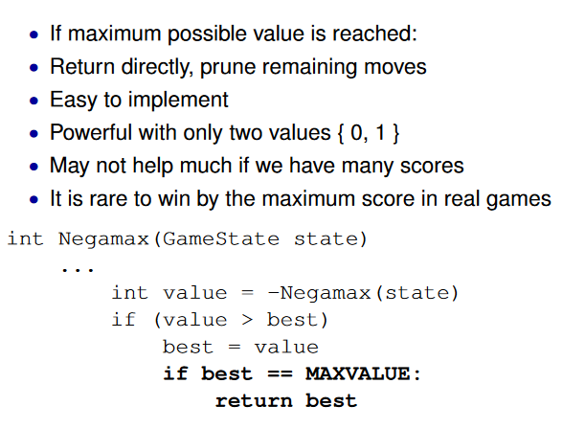
  - Other scenario is to reduce the search to a Boolean case if we find a value better than a bound
  - If we have a minimax value, we can use 2 boolean searches to verify it is. First search attempts to see if we can at least get it(scores greater than or equal to m are win else loss) while the second one searches if we can get more than it(scores greater than m are wins while less then or equal to are losses. For m to be mini max, in search 1, it must return a win and the second search must return a loss.
    - Then we can use this value to evaluate terminal stats and if it has a value greater than it, it’s a win and if its less, then it’s a loss
    - 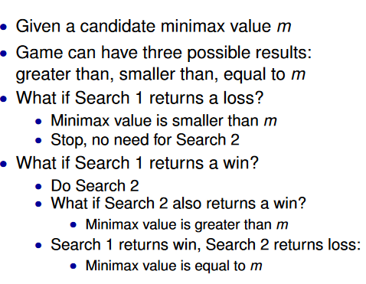
- For a proof tree for search 1, our winning strategy is to get at least m while we use a disproof tree for search 2 in which our opponents strategy is to stop us getting to m+
- These both prove that a player cant do better than m against perfect opponent
- We use Alpha-Beta if we have 2+ outcomes(think numerical scores)
  - We aim to store the lower and upper bounds (denoted alpha and beta respectively) of true minimax value and prune a position which falls outside this range
  - 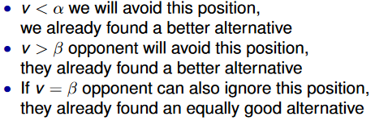
- Negamax styled Alg:
  - 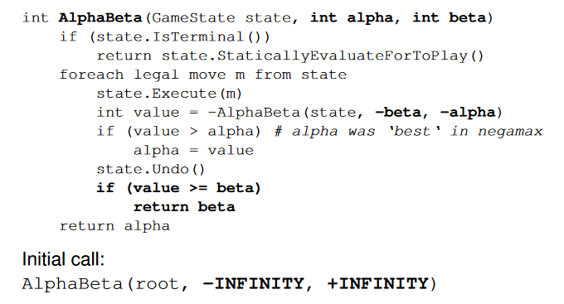
  - From current player PoV
  - Avoid separate cases for AND OR nodes as we negate scores when changing players
  - We negate range for opponents
  - 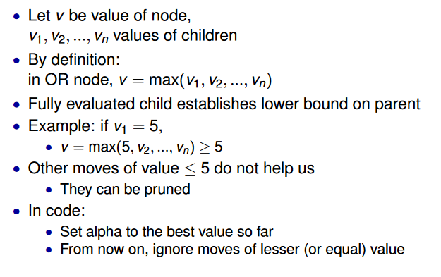
  - 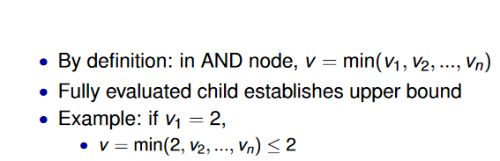
- The beta cut is the major idea for pruning
  - We return beta if the value is greater than or equal to beta
  - We can have a too good move as value>=beta is the same thing as value <=alpha for opponent. This means they can get alpha somewhere else and wont play the too good move for us
- A heuristic play is to stop search earlier and evaluate leaf nodes via heuristic
- We can limit the depth in our search to allow us to search for good move ordering
  - 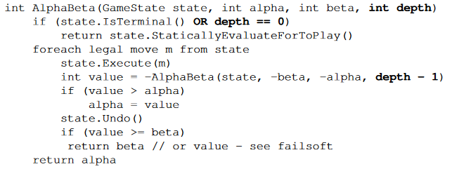
- Performance of Alphabeta and naïve negamax are similar due to pruning. Can become even better if added a heuristic
- Depth-limited Alphabeta:
  - 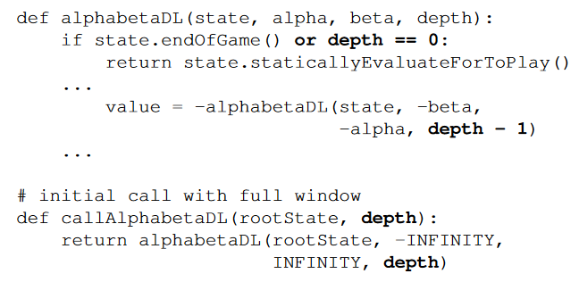
- Assuming minimax value of game is m:
  - 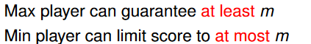
- We have the above two strategies stored explicitly if we store info about nodes in search
- 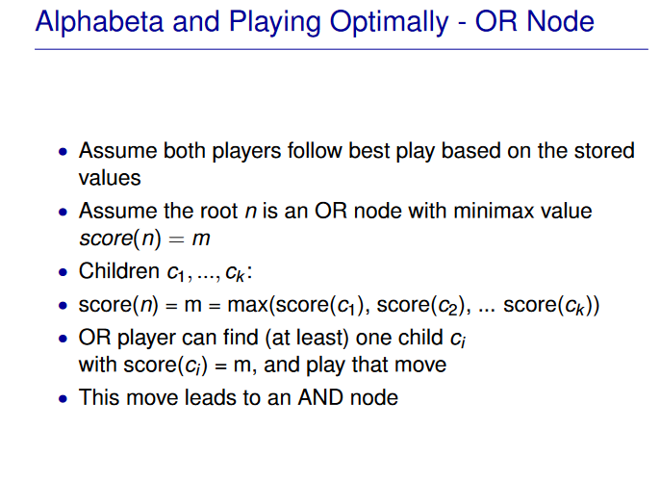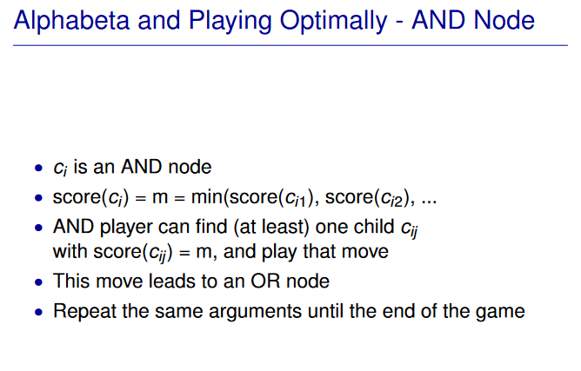
- Princple variation(PV): When both players play best move. This is a move sequence in which each node has a score of m
  - Only goes as deep as search
  - Nodes share value of heuristic evaluation of final sequential node
- If players both follow minimax proof route, they play out PV. If both follow said sequence, 2 proof trees are madem one for max, one fr min where S is the set of nodes for both trees
- We can use a hashing to cache search results and store them in a transposition table as we can get PV info and best move easily
  - Use a fixed size array or a python dictionary
  - Compute a has cose to use as postion \
  - We store data in pairs by using code for state and data of state as pairs
  - 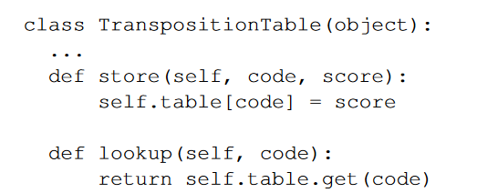
  - Much faster than without table
  - Not good with large searches and using a dictionary will fill memory very fast
  - Need to store only important states
- We use Zobrist Hash codes which is a good 64 bit code state.
  - We prep a random number code[point][colour] for each point color combination and then we use a bitwise xor over all points on board (either use ^ or import xor from operator library)
  - We need to get an array index from 64-bit code of state s
    - We can circumvent this by using an array of size 2^n and taking the first n bits of code(s) t use as index. To avoid collisions, we use full 64 bit
- For transposition tables:
  - We store only one bit for boolean negamax which is T/F minimax val of state
  - For alphabeta, we store:
    - Best move, search score, flags, search depth and whether it is exact result or heuristic score
- We can brute force enumerate over entire state space due to size of tictactoe board in that we try all legal moves and stop when game is over
  - Recall branching factor decreases with each play
  - 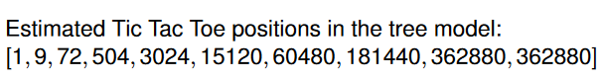
- Using a transposition table, we can skip the spaces we have visited and can count size of tic tac toe space
  - 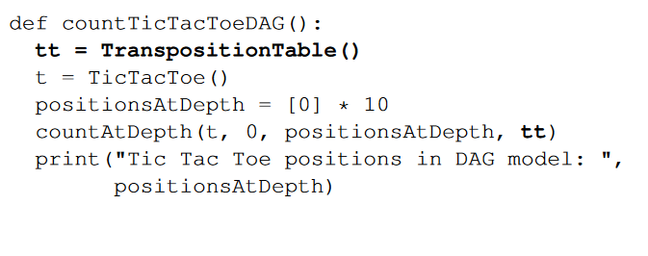
- To enumerate;
  - 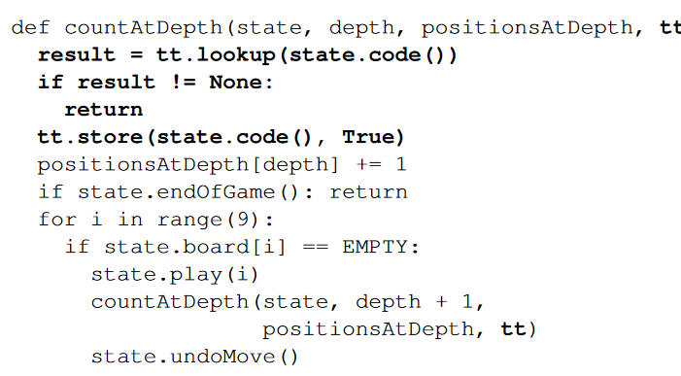
- For comparison:
  - 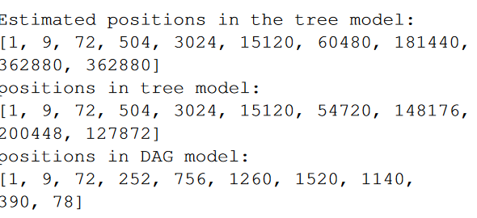
  - We visit much less positions in the DAG model
- With TTs, we can store all solved nodes in them
- Alphabeta is beta if strongest move is tried first
  - Window reduced the most and thus can cut out more moves
- A good heuristic is to try the strongest move from previous search
  - Keep track of moves which are effective in causing beta cuts in search and give them a bonus

- Even with perfect heuristic, need to cover all opponents move choices and this will not be sufficient to find a single path to goal
- Knowledge in heuristic search:
  - State and move evaluation
  - Search depth
  - Time control
- State evaluation
  - Mapping from a full state to one number
  - It measures how good that state is
  - Same thing as position evaluation/evaluation function
  - We know exact value in terminal states
  - Heuristic evaluation
    - Higher is better and is just a number. Could be estimate of game score
    - Decision making, order given by numbers only matter
      - Decides preference or ranking between moves
    - Leaf nodes of search evaluated
      - Heuristic evaluation of non-terminal states
      - Exact evaluation for terminal states
    - Interior nodes in search evaluated by minimax in which we go back up to parent all the way to root
    - A monotonically increasing function x>y f(x)>f(y)
    - Cardinal comparisons become important when you aggregate multiple evaluations
      - Some increasing mappings given same search behaviour when evaluations aggregated
    - All states with same evaluation are equally good and have same P(Win)
    - An evaluation function partitions set of all states S s.t.
      - Subsets S_v in which it is one subset for value v and all states in the same S_v are assumed equally good
    - If we are careful, using an exact and heuristic evaluation can allow us to get true proofs and losses. Importance of good heuristic a it speeds up exact proof
  - Winning probability
    - As above higher is better
    - Has interpolation as probability
    - Minimax score
    - No probabilities in game itself, perfect player would know with certainty
    - Machine learning used to learn estimates of win probabilities
- Move evaluation:
  - Mapping from an action/move to a number
  - Measure how good that current move is
  - Can be used to filter out moves
  - Also known as action/move value or Q-value
  - Given state and possible moves from states, put numeric value on each move
  - Can include/not include probabilistic interpretation
  - 2 interpretations involving move I given probability p_i
    - P_i =P(win) or P_i =P(best move) for move I
- If we have state evaluation but need move evaluation
  - Evaluate state after move
  - Can be slow if large branching factor
- If we have move evaluation and need state evaluation
  - Slow noisy result is to perform a greedy rollout followed by sequence of best evaluated moves and we still need to evaluate terminal state to get value
  - Random simulations are better
- We get evaluation knowledge from Machine learning techniques
  - Hardcoded rules
  - Simple features
    - Each feature is a Boolean statement about state/move and are easy to compute
    - Can construct evaluation function from this

  - Pattern databases
    - If we frequently use patterns from master games, we can learn them
    - Measure how often center move is played immediately or later
  - Neural nets
    - Knowledge= weights in neural net
    - Lower level encode local knowledge while higher levels express global evaluation
- Benson’s alg finds stones/territories which are unconditionally alive in that opponent can never capture stone no matter their play
- Monte Carlo Simulations main idea is to learn info from random sequences of decision steps
- Can be used for numerical integration
  - Very general
  - No assumptions on type of function to integrate and can also be used in higher dims
  - Need bounding box with object random point generator and a fast method to check if point is inside/outside object
  - High variance and slow convergence
  - Faster methods exist
- Monte Carlo came from Manhattan Project in 1940s by Ulam and von Neumann
- Markov Chain Monte Carlo
  - Simulate Random walks of paricles in which the walk is biased from physis constrains and the particle distribution is close to true distribution of what is measured
  - Used in image rendering by path tracing
- We need a model to able to simulate anything
- Garbage in Garbage out, simulation only good as model
- Given a Boolean formula, we assign true and false to the variables in such a way that make the formula true. Hence it is called satisfiable. Usually use heuristic search
- Note Boolean satisfactory Problem is abbreviated to SAT
- Systematic SAT solver:
  - Given n variables in formula
  - Set x_0 to True and solve for remaining formula and if fails, set x_0 to False
  - 2^n variable asssignments and exponential in n so could take a very long time to solve if not lucky
- Biased Random Walk(1990s):
  - We randomly assign T/F to variables and then use heuristics to flip one variable if not true. Restart if no progress
  - Exploitation: Flip variable which makes largest improvement while Exploration is just flipping a random variable
- Backgammon simulation:
  - Rollout games with different dice trhow sequences and play most successful
- Using random simulations for chance games is natural but without chance, its less natural and took a while to develop said methods
- TicTacToe simulate
  - End when board is full or three in row
  - 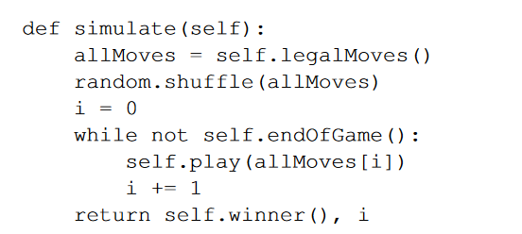
- To see if a game state is good:
  - Compute minimax value or run the solver
  - We also run simulations and score final result then get the win rate over all simulations
- A simulation based player uses 1-step lookahead to evaluate moves and for each move it will run n simulations and measure is winrate. Known as Flat Monte Carlo called so due to having a shallow tree
- Monte Carlo Method uses random simulations
- 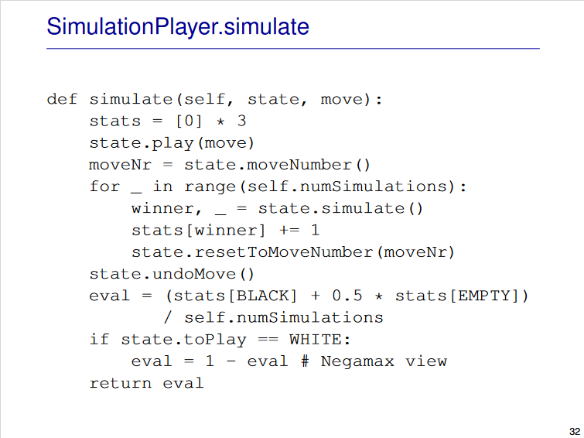
- 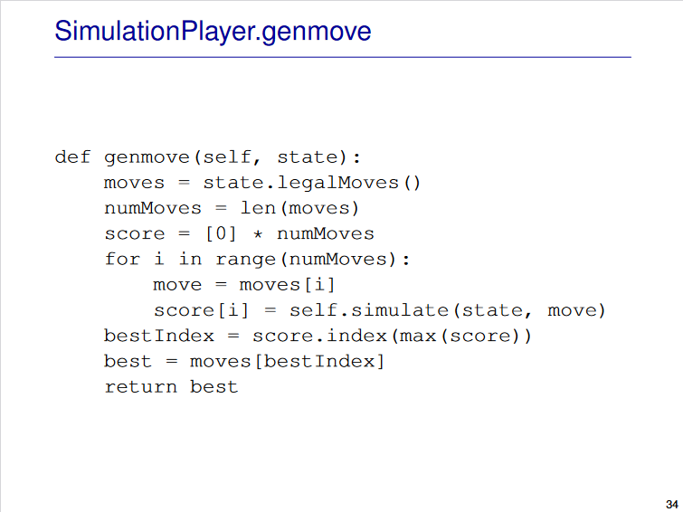
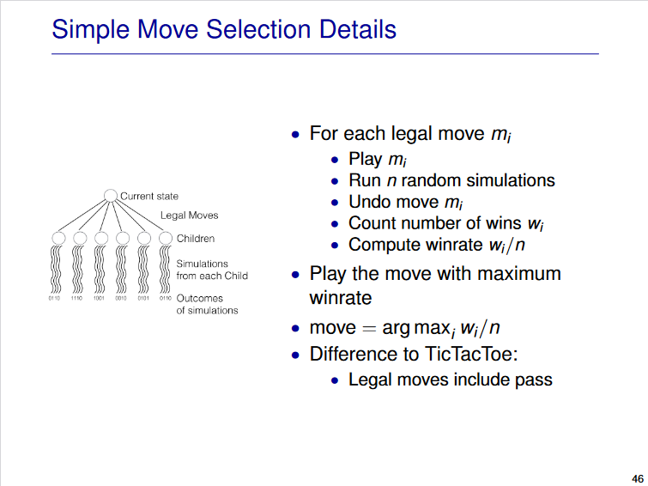

- Strength of Go3:
  - May simple tactics
  - Finds sure win near end
  - Avoid blunders random player may play
  - Up to a limit, as no of simulations increase, improves
- Weakness:
  - Assumes opponent is random as plays move best against random
- Ideal simulation preserves winds and losses exactly
  - If start pos is win/losssimulation is also win/losss
  - Implies every simulation is a perfect game with a perfect evaluation function
- Evaluation is the mean outcome of solutions which is the sum of simulation outcome/number of simulations
- Variance is the sum(simulation outcome-mean)^2 divided by the num of simulation
- An idea playout means we have a variance of 0 and thus mean=min_max score
- Real playout: means variance is greater than 0 and thus mean is not minmax score
- Bias is minmax score-mean
- MoGo= Monte Carlo Go Programs
  - Uses UCT and improved playout policy by tactical3x3 patterns
- Filter is what decided whether should be used or not
  - 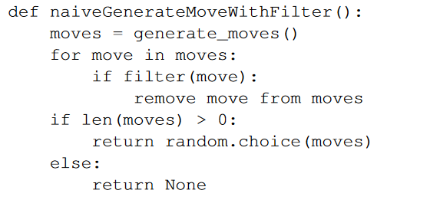
  - 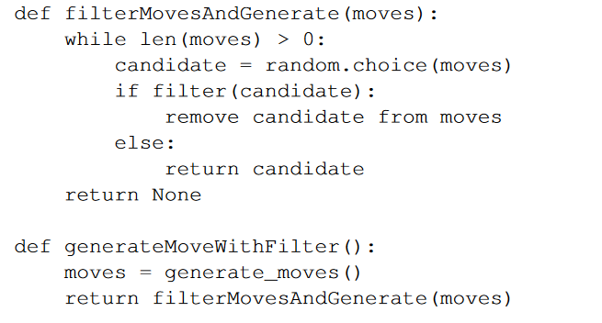
  - Moves would be in a list/array
  - To remove move at index I its to set I index to last element and pop
- Be in Atari-1 liberty
- Give Atari reduces opponents liberty to 1
- Selfatari is reduce ones own liberty to 1
  - 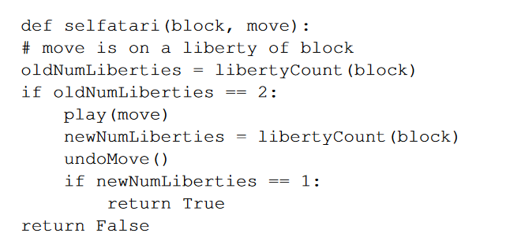
- Use both rules and filters to generate good moves
- 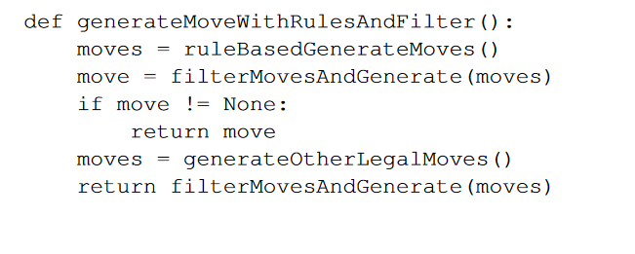
- Another way is to look at small loca area of move and decide if moves are good/bad based of stone pattern
- 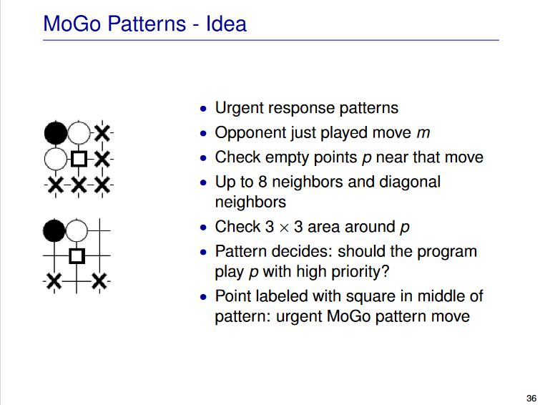
- 4 operations lead to symmetry with 16 different combinations
  - 2 rotations
  - 2 vertical flips
  - 2 horizontal flips
  - 2 colours swapping
- Wildcards match more than one game state(empty/B/W/Off board)
- Simulations must be stochastic or explore different sequences
- Variety in simulations is important as we got more information about state space
- Through randomness, we average out randomness
  - If no bias
- More samples= lower variance
- Recall policy types
  - Uniform random in which all legal moves are likely
  - Rule based in which all moves from a list are likely
- Probabilistic probability:
  - Play moves based off a probability
  - All probabilities sum to one
  - N legal moves for a position
  - Move I is chose with p_i
  - Use a heuristic to allow better moves to be more likely played and filter out bad probability moves
  - Uniform and rule based can be seen as this
- Heat map: red/orange are high probability, green is ok while blue is bad
- We don’t need many simulation too see a move is better than another thus we focus on higher % moves. Main idea of UCB
- Law of Large Numbers: Repeating an experiment multiple times gets results closer to expectation
  - As number of experiments(n) approaches infinity, the empirical frequency approaches p for an event E
- Bernoulli Dist: Random variable with 2 different values(only 2 outcomes)
  - P(X=0)=1-p and for P(X=1)=p given a fixed probability p
  - A Bernoulli Experiment is repeated many times for a fixed o and will draw from the distribution for p.
  - 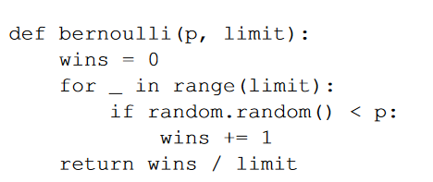
- Sampling from a game tree is a Bernoulli Experiment
  - Each leaf only has 1 or 0
  - Finite tree, leaves and paths to leaves
  - Fixed dist over children for simulation policy per node
- When we increase simulation number, winrate for child will stabilize due to law of large numbers, but if we do an infinite number of simulations, we will approach true winrate but can be fair from true minmax value
- More simulation +:
  - Lower variance
  - Better move selection when several moves are tied for first and rule out unlucky cases such as a Bad move winning may simulations or the opposite
- If we repeat a Bernoulli exp multiple times, win no is binomially distributed. Stored as B(n,p) in which is number of wins in n tries where each has a win probability p. To get expected value, n*p. As n increases, B(n,p)/n becomes centered around p
- Confidence interval is a range in which the true value is estimated to be in and a confidence level is the probability that the range contains true value
  - Low confidence level= more chance for error and smaller interval
  - High confidence level, larger interval and less chance for error to occur
- Separation: Whole confidence interval for best move is above all intervals of other moves
  - Aim here is to separate best move from others
  - Takes too long hence UCB which uses upper bound
- Bandit Problem: Run many simulations for each move and choose highest winrate move
  - Using Casino arms as an example, play each arm a select number then select based off results. Can leas to mistakes
- To measure mistakes we can do the following:
  - Use probability of making wrong choice
    - Arm I has best winrate p_i but we choose arm j with p_j<p_i
  - Simple regret
    - Simple regret is p_i – p_j in which j is out move and I is best choice, 0 if we chose best move
    - Each arm pull costs money
    - Used in most simulations
  - Cumulative regret
    - Sum of simple regret
    - Each pull costs something
    - UCB aims to minimize this
- UCB allocates simulations to moves smartly
- UCB(Upper confidence bound) Notations:
  - n_i number of times move I has been tried
  - Total sumlation number N=sum(n_i)
  - W_i: is number of wins for move I among n_i tries
  - Empirical winrate (mu_i)=w_i/n_i
  - Aim is to select best of k moves m_i in range 0<=i<=k-1
  - C is exploration constant and a larger C will require a larger confidence level
- UCB Formula+Loop:
  - 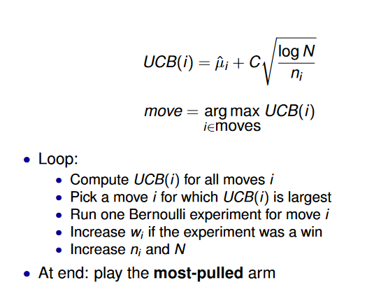
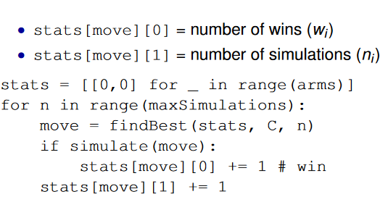
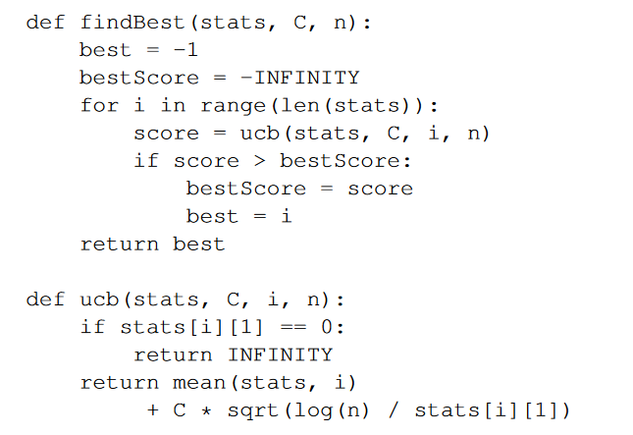
  - Note: if n_i=0 at beginning, to avoid div by zero, we can simulate each move once at start or return inf
  - To choose C, we can either tune for best result or we can use later theories to decide safe choice
  - To exit loop, we either use a fixed limit on total simulation number, stop at high confidence move or there is a single best move, it will have a high % of all simulations
- UCB vs Simple Simulation
  - UCB is more efficient and will quickly focus on small num of promising moves
  - UCB doesn’t stop exploring other moves due to log N
  - Only attempts bad moves rarely
- mu_i is the exploitation and thus prefer moves with high winrate
- Exploration: 1/n_i term prefer moves with large uncertainty, small n_i and log N term will never stop exploring, try bad moves eventually
- We can adjust C to deal with exploration/exploitation trade-off
- UCB is still only 1 ply deep
- Recall Negamax/Naïve Minimax
  - Explores full game tree and all children searched
  - Min over children at min nodes and max at max nodes
  - Exact and terminal nodes are true end of game
  - Uses only exact scores at termina modes for evaluation
- Recall efficient minimaxBoolean minimax/alphabeta:
  - Parts of tree are cut by pruning
  - Visit only one child for winner else try all moves for loser
  - Backup values are upper and lower bounds and not exact values
  - Exact
- Recall Depth-limited alphabeta:
  - Same as alpha beta but limited depth
  - Min and max values act as backups
  - Selective in that we perform herisitc evaluation at terminal nodes despite the search process being exact
- O(b^d/2) is too much even as best case so we perform selective searches by reducing both b and d till search is in budget
- Selective alphabeta search:
  - Depth limited and doesn’t consider all legal moves
  - Backs up result min and max
  - Its selective
  - Heurisitc evaluation at terminal nodes
  - Skips some legal moves
  - Source of error : Heuristic evaluation in leaf nodes and could also prune best move
- If we repeatedly sample in Simulation player:
  - We only sample moves close to start which doesn’t improve branching factor lower in tree with a small ssample number
  - We can eventually sample all nodes in full tree infinitely often or some subtree infinitely often when using a selective policy for large sample number
- Uniform random simulation policy:
  - Visits all nodes and only takes amx at root while averaging all simulations
  - Its selective but not exact due to averaging
  - Average can be far from min/max and large uncertainty with small sample
- Non-Uniform simulation policy:
  - All nodes except subtree below nonselected moves
  - Same as above
  - Selective
  - Avergae over better samples is closer to min/max
- MCTS(Monte Carlo Tree search):
  - Visits tree at start then simulations to finish
  - Takes weighted average over children whose weiht is no of simulations
  - Close to min/max if high weight
  - Selective
  - Deeper search for better moves
  - Converges to exact with time
- Using MCTS and UCT:
  - We add selective tree search
  - UCT adapts UCB to work on trees
  - Simulation is ruin from leaf of tree for evaluation
- MCTS:
  - Select: traverse existin tree using UCT to select child node
  - Expand: Add node to tree
  - Simulate: Follow simulation policy to end of game
  - Backpropogate: Update winrate along path to tree
  - Alg: 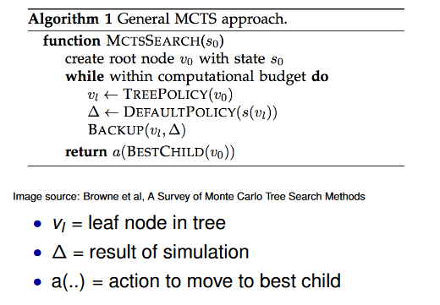
- MCTS Tree traversal:
  - Start from root
  - Go to best child and repeat till we reach leaf node using UCT
- UCT aims to balance focus on promising moves with focusing on moves where uncertainty about evaluation is high
- 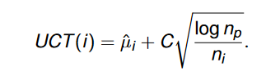 where n_p is simulation count of parent but exactly the same as UCT at root
- To grow tree we can add one node per iteration or from current simulation
- For MCTS simulation:
  - Use any sim policy
  - Run simulation from leaf node of tree
  - 1 or 0 is sim result
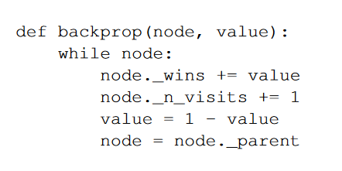
  - 1- Value switches from loss to win and win to loss
- Max child: highest num of wins
- Robust child: Select most visited root child
- While it can expand on best win rate, can explore inferior move
- Low sim count and high uncertainty could be selected
- Can use max robust child to help prevent above
  - Idea is if a move appears to be good, add more simulations to stabilize winrate but if fluke, confidence bound and winrate drop
- Machine Learning: The idea of letting a system learn from data, independently and data to data without being explicitly being programmed to do so
  - We can use this to learn from an evaluation function or a move generation policy
- Transposition table is an example of remembering facts
- Supervised learning: learning from labeled training data and is labeled with correct result
- Unsupervised: Unlabeled training data
- Reinforcement: Interact with environment and learn from rewards
- Semi Supervised learning: small amount of labeled and unlabeled training data
- Learning with a model allows us to try out actions and observe results in a simulator whereas learning from a experience allows us to learn from observations of the effect of real actions
- Given training data points, aim is to learn a function which maps x to y and ue it for prediction
- Training an test data must be independent
  - Split 90/10
- Overfitting occurs when u learn the noise as well as data, thus isn’t a good model for unseen data
- Underfitting is when we cant see th regularity in data from learned function
- Linear regression: y=ax+b in which a and b are the params to optimize which we use least squares to solve
  - We use square error to find difference y_i and ax_i+b as easier to optimize and also penalizes large errors
  - Square error is (y_i – (ax_i+b))^2 then we sum for all I values
- Input representation:
  - Raw input which I location of stones on the board/sequences of moves
  - Features which help learning such as liberties, patterns and proximity to last move and selfatari
- Model representation:
  - Simple to prevent overfitting but complex as needed to represent what we need
  - Functions which we have efficient learning algs and functions which represent general assumptions
- To develop model:
  - Create datadevelop modellearn weightsevaluate modelfind problems of data/model then repeat
- Output can be a good/bad move, filter/don’t for search or move evaluation/prob. We can also learn the state position/evaluation or local evaluation
Reading Notes:
- Reinforcement Renaissance
    - Deepmind is a google-owned AI based research center
      - Made an AI to play 50 different games such as Poing, Breakout, Space Invaders and Boxing using pixel positions and game scores.
    - In Jan. AlphaGo beat the European champion and in 2 months afterwards it ron 4 games out of 4 against the best go player in the world
  - DeepMind used a blend of:
    - Deep neural networks
    - Deep reinforcement learning
      - Model of learning where you’re not given a solution but aim to find it out by trial and error
  - Reinforcement learning is often contrasted with supervised learning which uses labeled examples whereas reinforcement learning doesn’t use labels
    - Better the moves, better the rewards (easy to tell)
  - Issue is determining which move leads to a win is hard
    - Delay between an action and its reward is difficult
    - Only receive feedback until end of game
  - Hundreds of actions till score increases
    - Score here refers to +1 for a win and -1 for a loss
  - Credit assignment problem: How can one tell which actions contributed to the reward and which wasn’t helpful
    - Reinforcement learning aims to solve said problem which is important for intelligence
  - Figuring out smart moves allows one to repeat those same situations again or try for a higher reward
    - Issue is it is very hard to get the same situation twice in many scenarios unless controlled in large scale games
    - Impossible to enumerate all possible scenarios
  - You need something that understands when similar situations that you’ve seen occurs
    - Neural networks help extract general features from more specific examples
  - Neural networks have multiple layers which learn more relevant features at higher abstraction levels
  - Deep learning is held back by the data
    - We can use reinforcement learning to automatically learn and generate data despite the data having a week label.
  - TD-Gammon (Temporal Difference) was made by IBms Gerald Tesauro used reinforcement learning to play Backgammon.
    - Deep learning= reinforcement learning with deep neural networks
  - Current inputs guide you to make next move
  - In principle, reinforcement can use past observations, experiences and existing knowledge to solve problems but humans are more capable of doing this
  - Part of intelligence is knowing what to remember
  - Cogitai: Software company which aims to use deep learning to make machines which, like humans, can learn from experiences
  - Devices could potentially get smarter not just from past experiences but from other devices experiences leading to better actions
  - Deep learning from scratch is very hard as there is littleto no experiences and therefore tough for real world AI problems.
    - One possible solution Osaro suggested is to show the model what good performance looks like and thus get a head start
- Kahneman and Tversky:
  - Decisions made in uncertainty
  - Consequences and outcomes unclear
  - Rely on heurstics: rule of thumb
  - Heuristics are useful but lead to biases and systematic error
  - 3 heuristics: allow us to think on our toes
    - Representatives: and overestimate relevancy of similar events and accurately predict likelihood of effect. Desire to link similar thing
    - Availability : How easily retrieved from memory or made from imagination.
    - Anchoring : When starting/reference point is given to subject and subjects rely on this too much. How we start with something and how it is ordered is very important
      - These occur on a daily basis.
- Intuition and reality:
  - System 1: Distinction that everybody recognizes in their own thinking. Thought that something happen to you and some thought u must generate.
  - System 2: 2 types of operations
    - Complex computations: pupil dilates and this is mental work(short term memory tasks)
    - Self control: inhibition of impulses. When choosing something carefully is an example of system
  - Correspond to experiences which are available
  - Distinction between something happening and something that one does
  - Dichotomy between S1 and S2
  - Interested in intuitive stats. Estimates coming to peoples mind
  - Distinguished intuition(error prone) from computation. Most should rely on later.
  - Never studied system 2
  - Was controversial
  - Created a situation which people could solve by working on it
  - Linda example
    - 30 yrs old now. When student, activist and marched on all the marches. Didn’t say feminist. Asked how likely is she a bank teller or teller and active in feminist movement. Most likely say feminist + bank teller. Ask to compare allows system 2 to work. Different process all together. Show one example, fits on that example but put things side by side, they can compare and provide another cue.
    - Attempt to resolve controversy
  - Anchoring: Someone puts number in head and looks plausible after a while. Hear something strange and try to make sense of fit. Basically suggesting effect. Can tell when being anchored
- Leave up to computer:
  - A
- Algorithms working lives
  - a
- 20yrs after deep blue

- Checkers are solved
  - A

